Final
Minutes
Monday, December 21, 2020
11:00 AM-12:00 PM
Via Zoom

Attendees: (taken from sign-in sheet – for those who signed in)
Robert Gary Anderson School
Renia Ehrenfeucht Architecture & Planning
Irene Vasquez Chicana & Chicano Studies
Melody Avila College of Nursing
Janie Chermak Economics
Norma Allen Budget Office

Excused:
Melissa Roberts Pharmacy

Absent: Marquita Harnett Law
Michael Davis Surgery Urology
Melissa Roberts Pharmacy
Osbjorn Pearson Anthropology
Sudharman Jayaweera Engineering

Guests: Barbara Damron UNM Cancer Center

Minutes: Felisha Martinez Office of the University Secretary

Meeting called to order @ 11:06 AM

Quorum was not met.

- Review and Approval of Agenda:
Quorum was not met; therefore, the agenda could not be voted on for approval.

- Review and Approval of Minutes
Quorum was not met, therefore the meeting minutes for Monday, October 19, 2020 could not be voted on for approval. This will be moved to the January 2021 meeting.

- Legislative Priorities
Barbara Damron
Dr. Damron presented on the university’s legislative priorities for FY22. She stated during the legislative special session in June 2020, there was a 4% cut to Instruction and General (I&G) funding as well as 6% cut to Research and Public Service Project (RPSP). Dr. Damron stated the revenue forecast has improved since this report was originally provided. Dr. Damron reported one goal is to maintain I&G. It was said there would be another 5% cut and now it is being reported it may be 2% at most. The university is hoping for no additional cuts to I&G. Dr. Damron stated the plan is also to fully restore federal funds swap to the I&G. State recurring money was replaced with non-recurring COVID relief money. This money was meant to be for COVID-19 testing, cleaning, etc. The university plans to ask for a compensation increase for recruiting and retention of current staff. In the past there was an unfunded mandate based on I&G. Dr. Damron stated this is because the university obtains funding from other sources. She gave the example that if there is a 5% salary increase, the increase averages out to 2% raise. Dr. Damron stated the university has been in touch with legislators in order to add more funding for employers to pay more into ERB rather than placing the increase on employees. She reported there are also plans to increase the Lottery Scholarship fund.
Dr. Damron stated requests for RPSP has gone through main campus and HSC. Some have requests for expansion to restore budgets back to FY21 prior to 6% cut as well as new program requests. Dr. Damron stated when cuts are made to academic agencies, cuts are also being made to state entities such as UNM Comprehensive Cancer Center, NM Poison and Drug Information Center, Office of Medical Investigator. As a result of budget cuts, it has created a backlog of services. Some entities provide services regardless if patients can pay (i.e., Cancer Center). Dr. Damron also reported new program requests such as Project for NM Graduates of Color. This program focuses on peer mentoring for graduates. The UNM United ECHO program focuses on teacher training in rural areas, which is also looking to restore its funds. It was reported that all existing RPSP will go forward.
Dr. Damron went on to discuss Capital Outlay Projects. She stated outlay projects are separate from general obligation (GO) bond money. Individual legislators are providing funds that come from STB and general fund money.

Projects include the following:
- College of Fine Arts Facility Renewal
- College of Pharmacy Building Planning and Design
- Essential Research Facilities Modernization
- Fire Safety Improvements
- Center of Excellence for Orthopedic Surgery and Rehabilitation at UNM HSC Rio Rancho Equipment
- UNM Comprehensive Cancer Center Radiation Oncology and Laboratory Expansion
- UNM HSC Simulation Activities Enhancement
- UNM Gallup Facilities Repair and Renewal
- UNM Los Alamos Infrastructure Renovations
- UNM Taos Infrastructure Improvements
- UNM Valencia Learning Commons Renovation

Dr. Damron stated the legislative session is scheduled to end March 20, 2021, however
could go into Fall 2021 as they can convene and recess at least 3
times.

- BLT Meeting Update
Norma Allen
Ms. Allen reported on the most recent BLT meeting. She stated BLT usually meet every two weeks during the Fall and Spring, however, have been meeting every month since July 2020. Ms. Allen then reported on short-term and long-term goals. BLT will be presenting recommendations to the regents the first week of April 2021.

Short-term Goal #1- Build the FY 22 Budget Recommendations
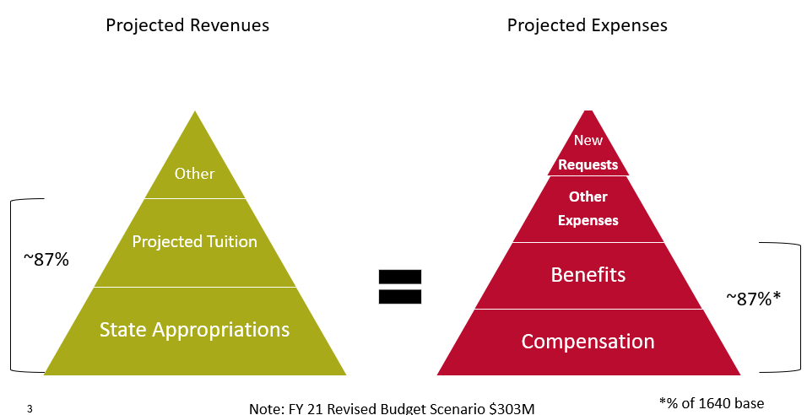
Ms. Allen reported state appropriations is the largest source of revenue. The legislative session begins January 2021 and the university is expecting potential cuts. The university is planning for 5% cut; however, the new estimate may be less. By March 2021, the university should know what state appropriation amount will be. Ms. Allen stated BLT will continue monitoring enrollments and adjust tuition and fee projections as needed. The Tuition and Fee team provided a proposal that states a 2.2% increase in resident undergrad and all graduate tuition. The proposal also includes a 5% increase in non-resident undergrad tuition. Ms. Allen reported regents approved the non-resident tuition over a 3-year period. The university will be going into its second year of the increase. It was reported the mandatory student fee proposal requests a 0% increase. This pays for Student Health Activity Center (SHAC), Student Union Building (SUB) and ethnic centers. Ms. Allen stated the proposal for SHAC is to pull out of Student Fee Review Board (SFRB) and have a stand-alone headcount fee of $95 for each semester (Fall and Spring). Summer semester will be reduced to $60. Ms. Allen reported a proposal to increase technology headcount fee to $150. This new rate eliminates the $100 online course fee and includes an additional $50 to cover new costs. She stated compensation, benefits, and other funding requests are to be reviewed in January 2021 and into March 2021.

Short Term Goal #2-Tuition and Fee simplification for students
Ms. Allen stated one part of this is to consolidate and simplify tuition and fee information. One example is to have the online course fee of $100 with the technology fee. She reported there is a plan to also simplify information on the Bursar’s website by combining various tuition and fee rates into a single rate (both undergraduate and graduate). Part of the simplification is also to simplify language and student’s bill as well as develop a tuition and fees calculator. Ms. Allen stated the university would also like to improve the financial aid/scholarship/tuition estimator on the Financial Aid website.

Long Term Goal #1-Develop an enterprise-wide multi-year financial model
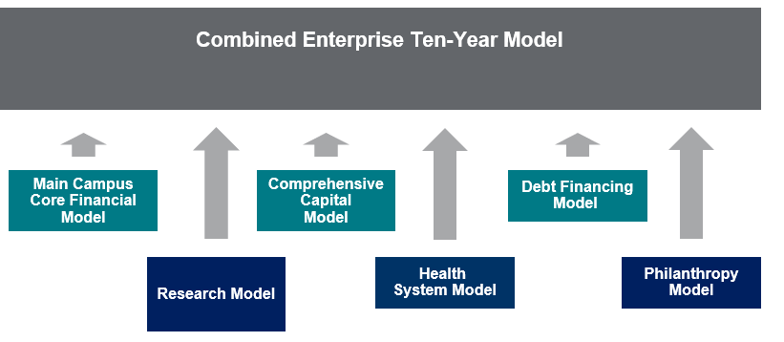
Ms. Allen reported the long-term goal of creating a 10-year model as a start of main campus core financial model, which is the I&G ($303 Million Budget). The goal is to look where the university is and where it is going. Ms. Allen stated there have been models for each unit, however not a comprehensive model for the university.

- Next Meeting
Monday, January 25, 2021

- Adjourned: 12:00 PM

