**Faculty Senate Library Committee (**[**website**](https://facgov.unm.edu/senate/rcw/library/)**)**

**Minutes**

December 15, 2022

Meeting ID: 957 0472 7994

**Attendees:** See below

**Meeting called to order:** 11:00 am

**Member Introductions**: Member introductions and welcoming of new members

**Approval of Agenda**: Approved

**Approval of minutes**:

April 14, 2022: Move to approve: Rich, Second: Stacy; Vote: 12 yes; 0 no; 3 abstain (completed online)

November 11, 2022: Motion to approve: Rich, Second: David; Vote: 12 yes; 3 abstain (completed online)

**Selection of Chair & Vice-Chair**: Tabled until spring.

**Report from Dean, CULLS: Leo Lo**

New website with information about strategic priorities for UL: <https://ulls.unm.edu/about/strategic-plan.php>

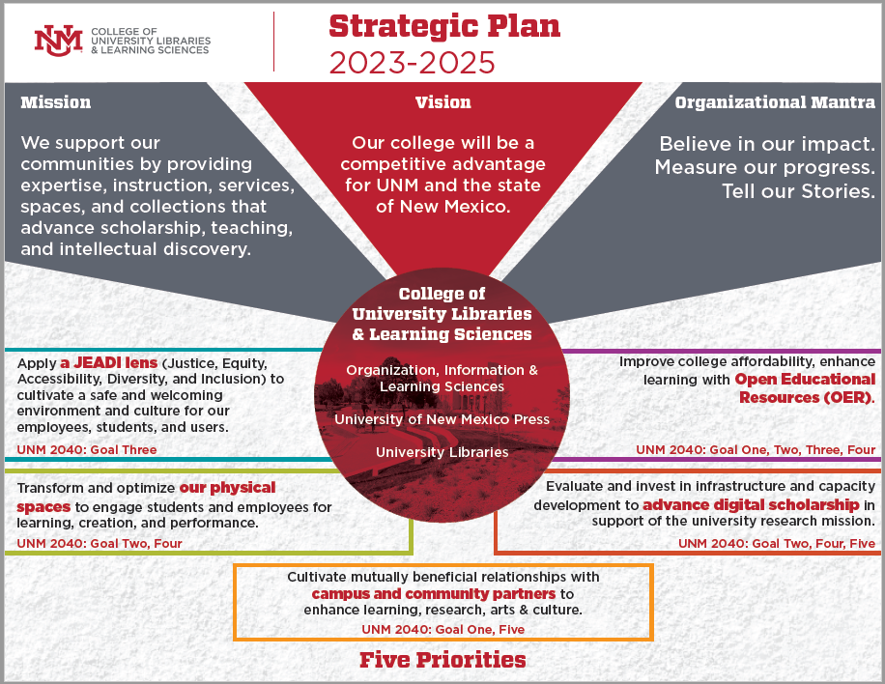

* Three faculty librarian searches ongoing.
* Upcoming priorities: 1) space planning (spaces for teaching/learning; graduate commons); 2) OER (college affordability and student success)
* Completed student survey this fall: 315 undergraduates. Majority enrolled full time+, majority working 20+ hours/week, impact of costs of course materials are significant. University-wide OER initiative will seek ways to address these impacts.
* Tracy Lassiter is organizing an event in the spring where OER information/training would be an asset. Leo asked her to send the information about her event so he can set up the correct presenter.
* Brief discussion of role/priorities of the OER working group, focus on raising awareness and designing incentives during the first year of its work.
* New program to recognize accomplishment of faculty receiving tenure: newly-tenured faculty will be able to select a book (personally or professionally significant) that will be added to the library’s collection along with a digital bookplate.

**Report from Law Library: Michelle Rigual, Director** (Given by Jennifer Laws)

* Construction still supposed to happen in January, no update.
* The Law Library continues to rebuild staffing.

**Report from HSLIC: Melissa Rethlefsen, Director**

* Study rooms being renovated over the next few weeks, with student input from focus groups. ADA restroom being installed on main floor. Additional renovations planned for the second floor, seeking funding for that effort.
* Donation of anatomical models has been received.
* View the anatomage table: <https://anatomage.com/table/>
* <https://libguides.health.unm.edu/anatomage-table>
* Two new e-book packages have been added to the HSLIC suite of resources.
* NIH rules of data management and sharing going into effect January 5. HSLIC is teaching classes on the policy and supporting researchers with compliance. They will host drop-in sessions in January to support submissions from researchers – connect them with the data management specialist. Sign-ups are on the HSLIC website events calendar page.
* Rigor and Reproducibility journal club: topics and research from multiple disciplines, open to students, Melissa is a contact for questions.
* Jeremy Yang will chair the HSLIC advisory committee.
* Two library faculty hires are in process. HSLIC also now offers student peer information partner to support students with research questions who may be intimidated about meeting with a librarian.

**Announcement**:

* UL undergraduate research award – process now open: <https://library.unm.edu/awards/index.php>
* Submissions due February 6, main campus students only, for work done in calendar 2022

**Future and Goals for Committee:**

* 16 members, both inside and outside the UNM libraries, plus 3 library directors ex-oficio
* Committee Charge: <https://handbook.unm.edu/a65_1/>
* Question: how to facilitate communication, especially transmission of the information shared in the reports to this committee?
* Member question: can a faculty member share concerns from peers directly with library directors during the committee meeting? Answer: yes! This is a space to bring concerns.
* Do the libraries focus on branding, communicating value across campus – are these topics discussed in this meeting? Sometimes yes, sometimes no.
* Involvement of branch librarians, as committee members and communication points, can be one way to keep information and ideas flowing across the institution.
* There are opportunities for the Library Committee chair to make summary reports to the FS Operations Committee.
* Communication of library as source of expertise rather than just a space – important for graduate students in particular.
* What are the library priorities that faculty can work to support, share information about? OER; space planning; student perceptions; financial/budget advocacy;
* More budget info, along with comparison to peer institutions: <https://libguides.unm.edu/librarybudget>
* HSLIC strategic plan: <https://hsc.unm.edu/hslic/about/strategic-plan.html>

**Meeting adjourned at 12:04**

**Next meeting: To Be Scheduled**

**Attendees:** Kathryn McKnight (A&S, Humanities; Committee Chair)**,** Rich Brody (ASM),Jennifer Laws (Law),Deborah Rhue (HSLIC),Tamara Shannon (Nursing), Colin Olson (A&S, Social Sciences),Tracy Lassiter (Gallup),Glenn Koelling (CULLS),Owen Whooley (A&S, Social Sciences),David Weiss (A&S, U. College), Leo Lo (Dean University Libraries, Ex oficio),Marios Pattichis (Computer Engineering),Melissa Rethlefsen (HSLIC Director, Ex oficio),Julia Scherba de Valenzuela (Special and Bilingual Education)

**Absent:** Mohammad Motamed (Math & Stats), Hallie Brown (GPSA Rep.), Michelle Rigual (Law Library Director, Ex oficio), Stacia Smith-Alexander (Theater and Dance), Mark Morgan-Tracy (Physics & Astronomy)